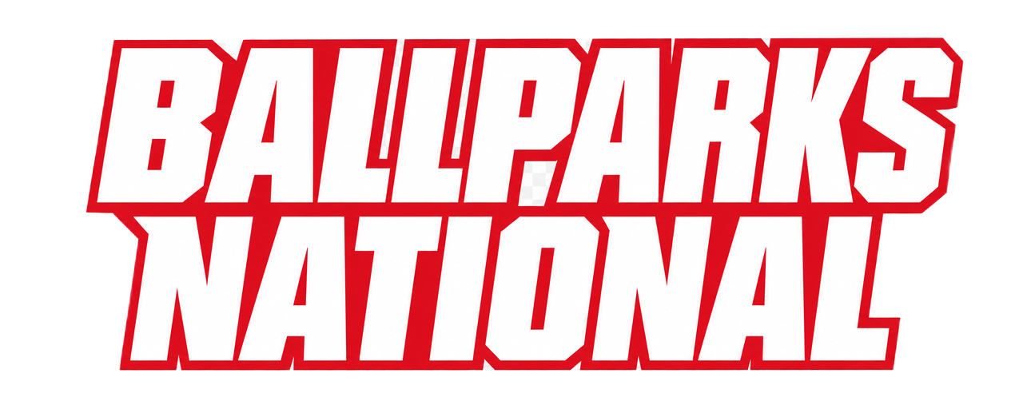

PREPARED EXCLUSIVELY FOR
JORDAN BRAND
Corporate Naming Rights
& Partnership Proposal
A Title Partnership Opportunity at Ballparks National

Prepared by the 360 Sports Group Partnerships Office
682-220-0899 · dmiller@360sportsgroup.com

BALLPARKS NATIONAL
WHERE THE GAME MEETS THE LAKE
JORDAN BRAND
Corporate Naming Rights & Partnership Opportunity
Ballparks National is a destination sports complex on the Lake of the Ozarks, Missouri, purpose-built to host World Series–caliber baseball and softball across 8 championship diamonds, plus an outdoor multi-sport complex (soccer, lacrosse, football & field hockey) and a Phase 2 indoor complex for volleyball, basketball and indoor club sports. It is anchored by The Lab — the next phase of Ballparks National: a technology-driven player-development center where motion capture, ball & bat tracking, and force-plate biomechanics power elite training. The complex draws hundreds of thousands of families, athletes, and coaches every season.
425K+ Annual visitors | 8 Championship diamonds | 10+ Sports hosted
$7.8M — 5-yr est. media value | 205M — Annual impressions | 15 yr — Max partnership term
Why Title Naming Rights Wins
- Identity: Your name becomes the destination — every event, ticket, schedule, and direction references your brand.
- Broadcast: Front-and-center signage on every livestream and highlight reel across all sports.
- Exclusivity: Category exclusivity locks competitors out of the entire complex for the full term.
- Reach: Millions of organic impressions from families, teams, and travel networks across 10+ sports each season.
- Growth: First right of refusal on all new facilities — including the Phase 2 indoor complex — expansions, and renewals.
- Activation: Year-round retail pop-ups, sampling, camps, MVP awards, and naming of marquee events.
The Destination Advantage
Prime Location | Multi-Sport Scale | Stay & Play
On the Lake of the Ozarks — within a day’s drive of 40M+ people. | 8 diamonds, an outdoor multi-sport complex, and a Phase 2 indoor complex for volleyball & basketball. | On-site lodging, dining, and retail keep families on campus 3.5 nights per event.

MARKET & AUDIENCE
A Growing, High-Value Audience
Youth travel sports is one of the fastest-growing segments in America — a $40B+ annual market. By hosting baseball, softball, outdoor field sports, and indoor club sports on one campus, Ballparks National converts that momentum into sustained, repeat foot traffic and a captive family audience with real purchasing power.
$40B+ U.S. youth-sports economy | 3.5 nights Avg. family stay | 68% Return next season
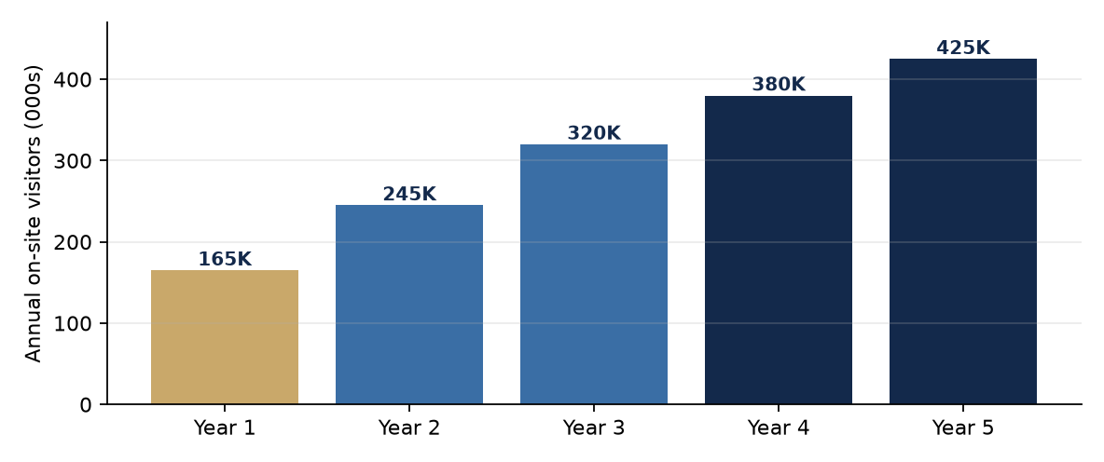
Figure 1 — Projected on-site attendance ramps to 425K annual visitors by Year 5.
Who Attends
Families make up the majority of on-site traffic — the exact decision-makers brands compete to reach. Coaches, scouts, and college recruiters add a high-influence tier across every sport. Every visitor passes branded signage an average of 14 times per event, compounding impressions across a multi-day stay.
40M+ Within a day’s drive | 22 States / season | 14× Signage views / visit

PARTICIPATION & PROGRAMMING
A True Multi-Sport Destination
Ballparks National now hosts 10+ sports across its diamonds, outdoor multi-sport complex, and Phase 2 indoor complex. That breadth diversifies attendance, lengthens the calendar into every season, and multiplies the branded touchpoints a partner reaches.
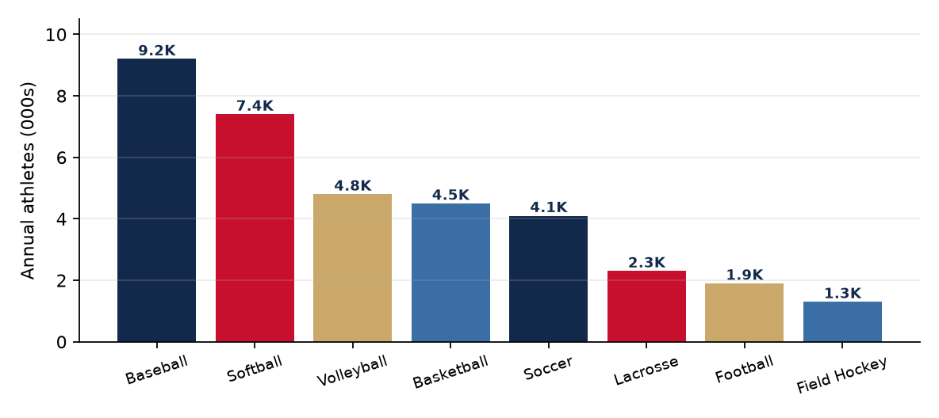
Figure 4 — Projected annual athlete participation by sport at complex maturity.
Venue | Sports | Peak season
8 Championship Diamonds | Baseball, softball | Spring–Summer
Outdoor Multi-Sport Complex | Soccer, lacrosse, football, field hockey | Spring & Fall
Phase 2 Indoor Complex | Volleyball, basketball, indoor club sports | Fall–Winter
The Lab | Player development & training (all sports) | Year-round
Why Multi-Sport Depth Matters to Partners
- Year-round exposure: Diamond, outdoor field, and indoor seasons stack into a 12-month activation calendar.
- Broader audience: 10+ sports pull distinct family, club, and recruiting audiences to the same branded campus.
- More inventory: Courts, multi-sport fields, and the indoor complex add high-value naming assets beyond the diamonds.
- Diversified attendance: Volleyball and basketball anchor fall/winter traffic baseball and softball can’t reach.

MEDIA & BRAND EXPOSURE
Where Your Brand Shows Up
A naming-rights partnership delivers year-round, multi-channel exposure — not a single event. Broadcast and streamed tournaments across all sports, an active social ecosystem, permanent signage, and every digital schedule and ticket combine into an estimated 205 million impressions annually.
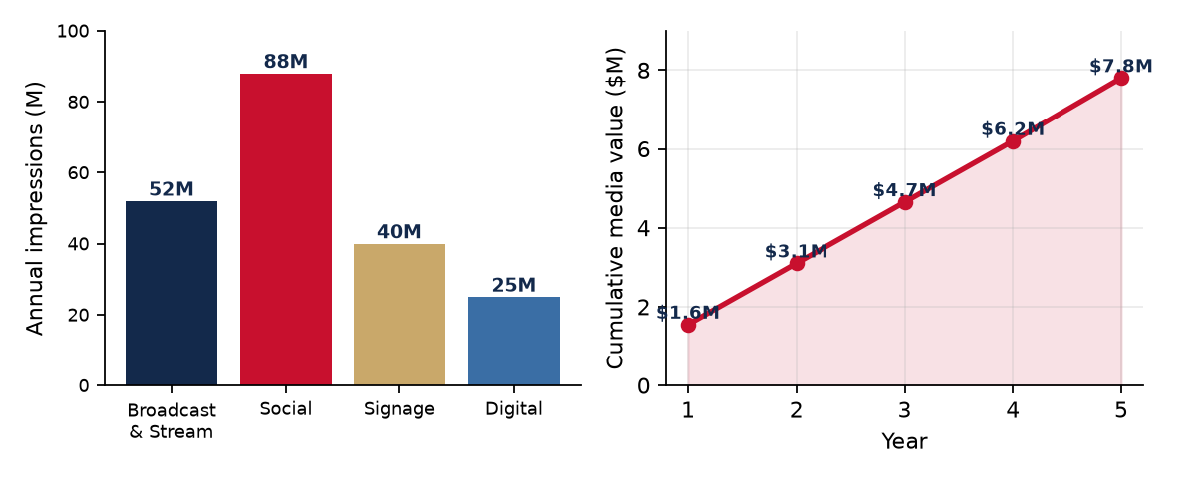
Figure 2 — Impressions by channel (left) and cumulative estimated media value over a 5-year term (right).
- Broadcast & streaming: 52M+ annual views across tournament livestreams and highlight distribution.
- Social media: 88M+ organic impressions from families, teams, and multi-sport networks.
- Permanent signage: 40M+ on-site impressions across diamonds, fields, indoor courts, plaza, and The Lab.
- Digital footprint: 25M+ impressions on schedules, tickets, apps, and the event microsite.
Independent valuation places the cumulative media equivalency of a title partnership at approximately $7.8M over five years — before hospitality, activation, and category-exclusivity value.
Year-Round Activation Calendar
Season | Signature activation opportunities
Spring | Season-opening showcases, gear reveals, sampling at first diamond & soccer tournaments.
Summer | Peak travel-ball championships, multi-sport tournaments, camps & clinics, MVP awards, retail pop-ups.
Fall | Recruiting showcases, The Lab combine events, football & field-hockey events, skills competitions.
Winter | Indoor volleyball & basketball leagues in the Phase 2 complex, off-season data & development at The Lab.

PARTNERSHIP INVENTORY
Full Naming-Rights Inventory
Beyond the title sponsorship, every surface of the complex is available — individually or bundled. Ranges are illustrative starting points for multi-year agreements and are tailored per partner.
Asset | Description | Qty | Investment | Term
Title / Presenting Rights | Entire complex — “[Brand] Ballparks National” | 1 | $1.5M–$3M/yr | 10–15 yr
Phase 2 Indoor Complex | Volleyball, basketball & indoor club-sport venue | 1 | $500K–$900K/yr | 7–10 yr
The Lab — Player Dev Tech | Motion capture, tracking, biomechanics & analytics | 1 | $400K–$750K/yr | 7–10 yr
Outdoor Multi-Sport Complex | Soccer, lacrosse, football & field-hockey fields | 1 | $250K–$500K/yr | 5–10 yr
Championship Stadium Field | Premier broadcast diamond & grandstand | 1 | $150K–$300K/yr | 5–10 yr
Championship Diamonds | Individual lighted competition diamonds | 8 | $40K–$90K/yr | 3–5 yr
Indoor Courts | Hardwood / multi-sport courts | 6+ | $25K–$60K/yr | 3–5 yr
Performance & Strength Ctr | Athlete training / weight room | 1 | $50K–$120K/yr | 5 yr
Locker Rooms / Clubhouses | Branded player locker & team rooms | 10+ | $15K–$35K/yr | 3–5 yr
Batting Cages & Tunnels | Indoor/outdoor hitting & pitching lab | 10+ | $10K–$25K/yr | 3–5 yr
Entry Plaza & Main Gate | Walk-of-fame arrival experience | 1 | $75K–$150K/yr | 5–10 yr
Concourse & Concessions | Branded food court / fueling station | 1 | $40K–$80K/yr | 3–5 yr
Scoreboards & Video Boards | LED scoreboards and ribbon boards | 14+ | $8K–$20K/yr | 3–5 yr
Dugouts | Branded dugout pairs across all fields | 16+ | $5K–$12K/pr/yr | 1–3 yr
Hydration / Fueling Stations | Beverage stations complex-wide | 24+ | $30K–$75K/yr | Cat.-excl.

INVESTMENT & RETURN
Investment Ladder & ROI
Entry points span from single-asset activations to flagship title rights, so partners can scale involvement to budget and objective. Every tier compounds impressions across a multi-day, multi-sport season.
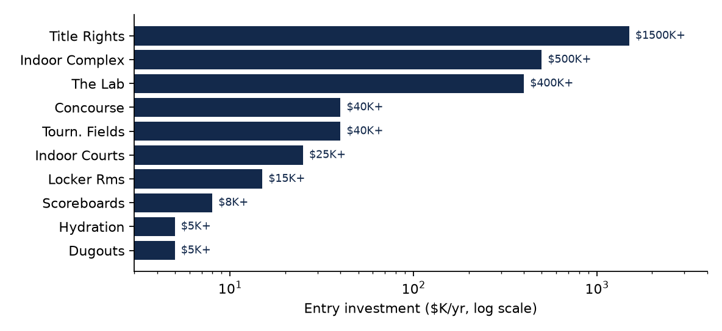
Figure 3 — Entry investment by asset tier (logarithmic scale, $K per year).
Compare Partnership Tiers
Tier | Investment | Reach | Exclusivity | Naming
Title Partner | $1.5M–$3M/yr | Entire complex + all events | Full category | “[Brand] Ballparks National”
Indoor Complex | $500K–$900K/yr | Volleyball, basketball & club sports | Indoor category | “[Brand] Indoor Complex”
The Lab | $400K–$750K/yr | Player development & training | Tech / training | “The Lab by [Brand]”
Outdoor Multi-Sport | $250K–$500K/yr | Soccer, lacrosse, football, field hockey | Outdoor field sports | “[Brand] Fields”
Term & Payment Flexibility
- Multi-year terms: 1–15 year agreements structured to the asset and partner objectives.
- Scalable entry: Start with a single asset and expand via first-right-of-refusal on new inventory.
- Blended value: Cash, product/VIK, and activation commitments can be combined to fit budgets.
- Renewal protection: Right of first refusal and category exclusivity carry through renewals.

YOUR RECOMMENDED PARTNERSHIP
Recommendation for JORDAN BRAND
A tailored naming-rights recommendation for JORDAN BRAND — best-fit assets, strategic rationale, and the correct department and contact channel.
Recommended Package | Anchor the Phase 2 Indoor Complex or The Lab — Jordan Brand resonates with elite youth-athlete culture, basketball, and indoor training.
Why It Wins | Jumpman branding on the marquee indoor complex and hardwood courts; flagship court/turf identity for volleyball & basketball; signature athlete appearance opportunities. (Division of Nike — same submission path.)
Department | Jordan Brand — Sports Marketing (a division of Nike)
Contact | Jordan Brand c/o Nike, Inc.  One Bowerman Drive, Beaverton, OR 97005  Phone: 1-800-806-6453 • Via Nike Sports Marketing
Route To | Jordan Brand Sports Marketing — Court/Training
Next Steps
1. Select a flagship target and tailor the title or anchor package to the brand’s goals.
2. Route the proposal to the named department; secure a warm introduction where needed.
3. Present the activation calendar, multi-sport audience data, and exclusivity terms.
4. Finalize a multi-year agreement with renewal and first-right-of-refusal clauses.
Let’s Build This Partnership
Ready to position JORDAN BRAND at the center of the fastest-growing arena in youth sports? Contact the 360 Sports Group Partnerships Office to tailor this package.
Dave Miller • 682-220-0899 • dmiller@360sportsgroup.com • Lake of the Ozarks, MO

PARTNER ADD-ON BENEFIT
QR-Powered Social Media Campaign Strategy
Every tournament weekend brings thousands of players, families, coaches, and fans to Ballparks National — a captive, phone-in-hand audience. This program converts that in-person foot traffic into measurable, compounding social reach for the facility and its naming-rights partners. Strategically placed QR codes across the venue make it effortless for visitors to follow, tag, share, and create content, turning every event into a self-perpetuating marketing engine that grows all Ballparks National social platforms — and every co-branded partner impression — at once.
The program runs on a simple loop: Scan → Follow → Create → Share → Amplify. Each touchpoint removes friction, rewards participation, and cross-promotes every platform, so a single scan can grow Instagram, TikTok, Facebook, X, and YouTube simultaneously.
Why It Matters for This Partnership
- Guaranteed impressions: Co-branded QR codes and landing pages tie the partner logo to 325K+ annual on-site visitors.
- Measurable ROI: UTM-tracked codes report exact scans, follows, and user content generated per sponsor.
- Always-on activation: “Scan-to-Win presented by [Partner]” places the brand on every entry, every weekend.
- Highlight integration: Sponsor bumpers ride on daily highlight reels distributed across all platforms.
- Compounding reach: Participant-generated posts extend brand exposure well beyond the fences.
QR Placement Map — Where Codes Live
Location | Call-to-Action | Primary Goal
Main entrance & check-in | “Scan to follow the action all weekend” | Follows
Dugouts & player benches | “Tag your team — get featured” | User content
Scoreboards & field signage | “Live scores + highlights here” | Follows / retention
Concessions & merch stands | “Scan for today’s deals & giveaways” | Follows / conversion
Bleachers & family seating | “Share your game-day moment” | User content
The Lab / training areas | “See the tech behind the training” | Brand story
Parking & exits | “Miss a moment? Watch the recap” | Retention

Signature Campaign Playbook
#PlayedAtBPN — The Signature Hashtag
Every QR landing page prompts visitors to post with #PlayedAtBPN. A live feed on facility screens and the website pulls tagged posts in real time, so participants see their content on-site — a powerful incentive to keep posting. Weekly winners get reshared and rewarded.
Scan-to-Win Giveaways
Concession and merch QR codes enter visitors into weekend prize drawings. Entry requires a follow + tag, directly converting foot traffic into followers and co-branded sponsor impressions.
Play of the Day / Highlight Reels
Dugout and bleacher codes let families upload clips. The best are curated into daily reels across TikTok, Reels, and YouTube Shorts, tagging teams so they reshare to their own followings.
Team Spotlight & Livestream Hub
Coaches submit rosters via a dedicated QR for guaranteed spotlight posts, while a “Watch Live” code routes remote families and recruiters to livestreams — keeping off-site audiences subscribed.

Cross-Platform QR Toolkit
Each production-ready code below points to a Ballparks National channel. The Social Hub code is the hero — a single scan follows every platform at once and drops the visitor into the live #PlayedAtBPN feed. These are printed on signage, table tents, wristbands, and jumbotron slides throughout the facility, and can be co-branded with the partner logo.
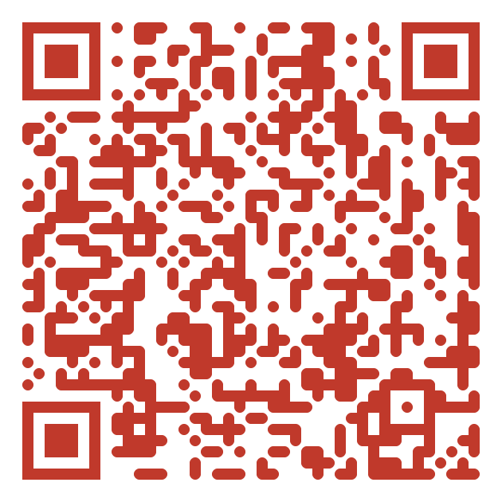 | 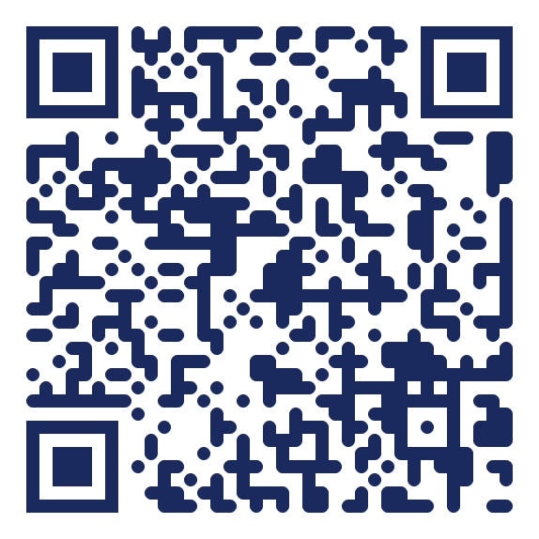 | 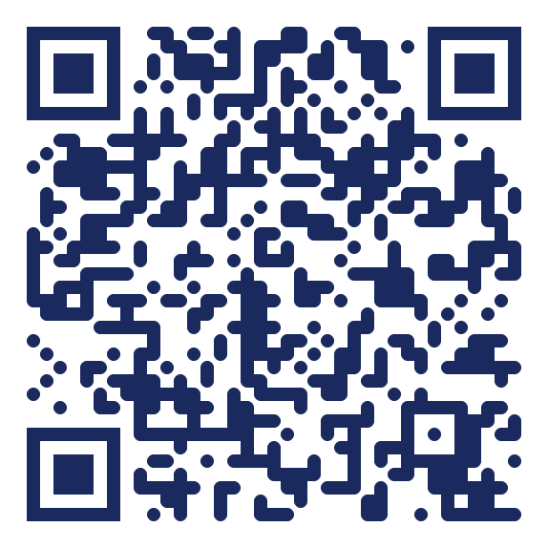
Social Hub | Instagram | TikTok
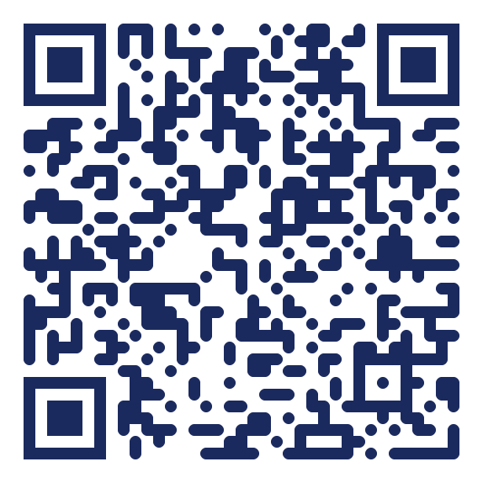 |  | 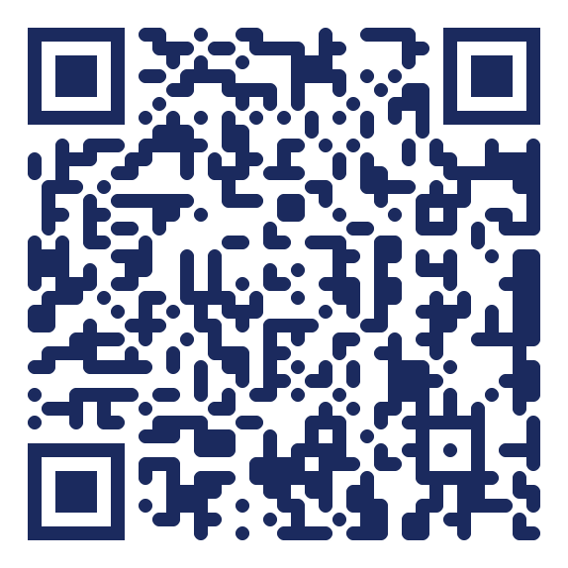
Facebook | X / Twitter | YouTube
Note: QR destinations are wired to the Ballparks National domain and can be repointed to final handles or a UTM-tracked, co-branded landing page before print.

Measurement & 90-Day Rollout
Metric | How It’s Tracked | Target (Year 1)
QR scans per event | UTM / QR analytics | 8,000+ / weekend
Net new followers | Platform insights | 25,000+ annually
#PlayedAtBPN posts | Hashtag tracking | 500+ / weekend
Livestream views | YouTube analytics | 10,000+ / event
Sponsor impressions | Landing-page logs | 2M+ annually

Phase | Timeline | Key Actions
Build | Days 1–30 | Finalize handles & UTM landing pages, design co-branded QR signage, set up hashtag feed.
Launch | Days 31–60 | Install QR touchpoints facility-wide, train staff, run first Scan-to-Win at a live tournament.
Optimize | Days 61–90 | Review scan analytics, double down on top touchpoints, activate partner co-brand.

HERO POSTER SERIES
QR-Activated Social Campaign · Printed & Placed Throughout the Ballpark
Blockbuster, movie-style posters are printed at poster size and strategically placed throughout Ballparks National. Each carries a scannable QR code that funnels tournament participants and families into our social platforms, livestreams and giveaways — turning every visitor into a brand amplifier. As the naming rights partner, Jordan Brand's brand rides on every scan, share, and stream generated by these posters across the entire facility.

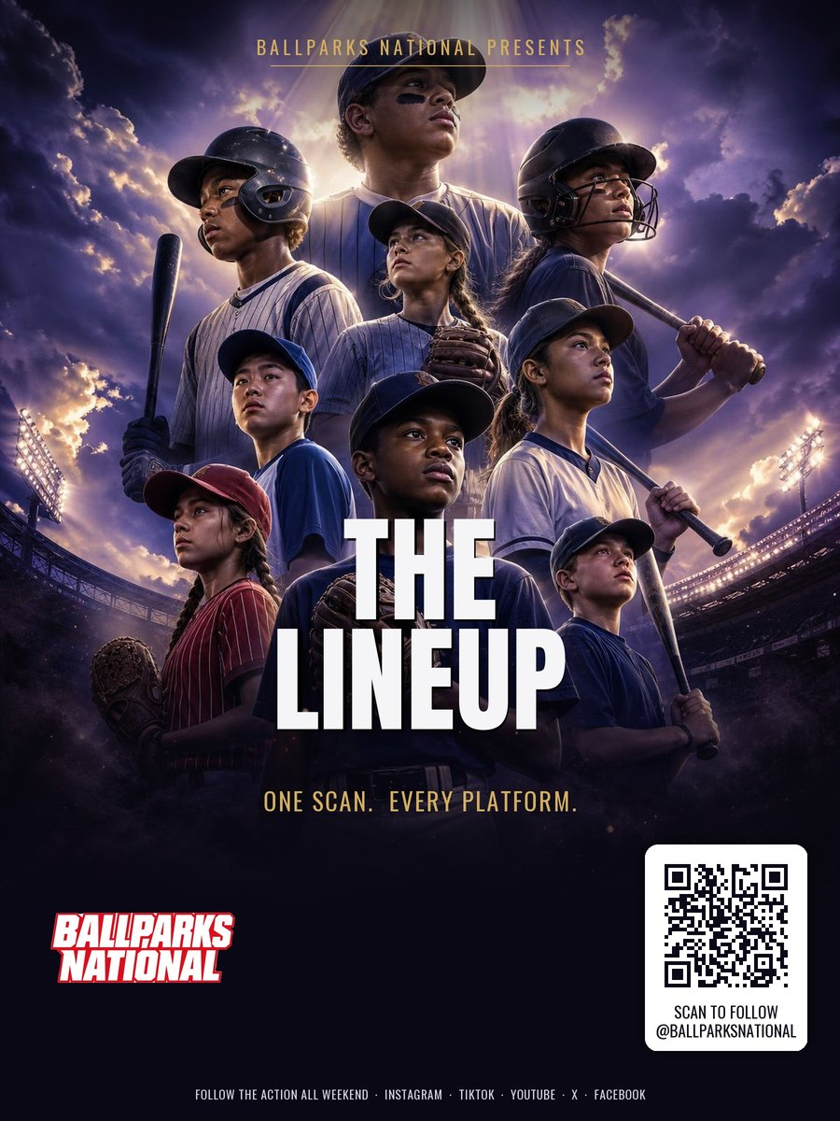
THE LINEUP — One Scan · Every Platform
Flagship ensemble hero shot. Anchors the single-scan Social Hub.

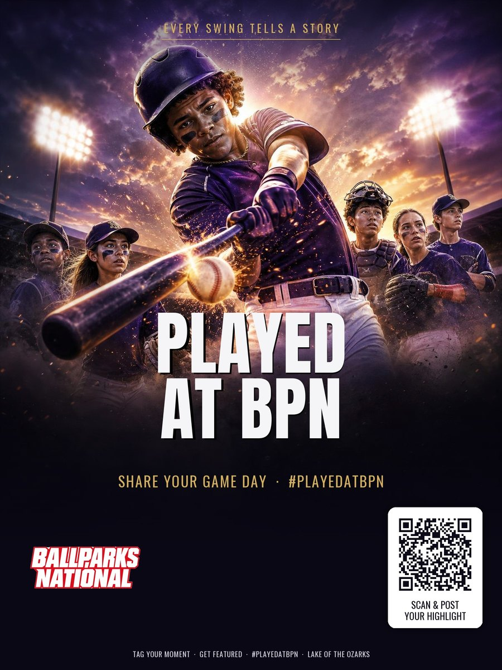
PLAYED AT BPN — #PlayedAtBPN
Turns every participant into a creator, driving user-generated content.

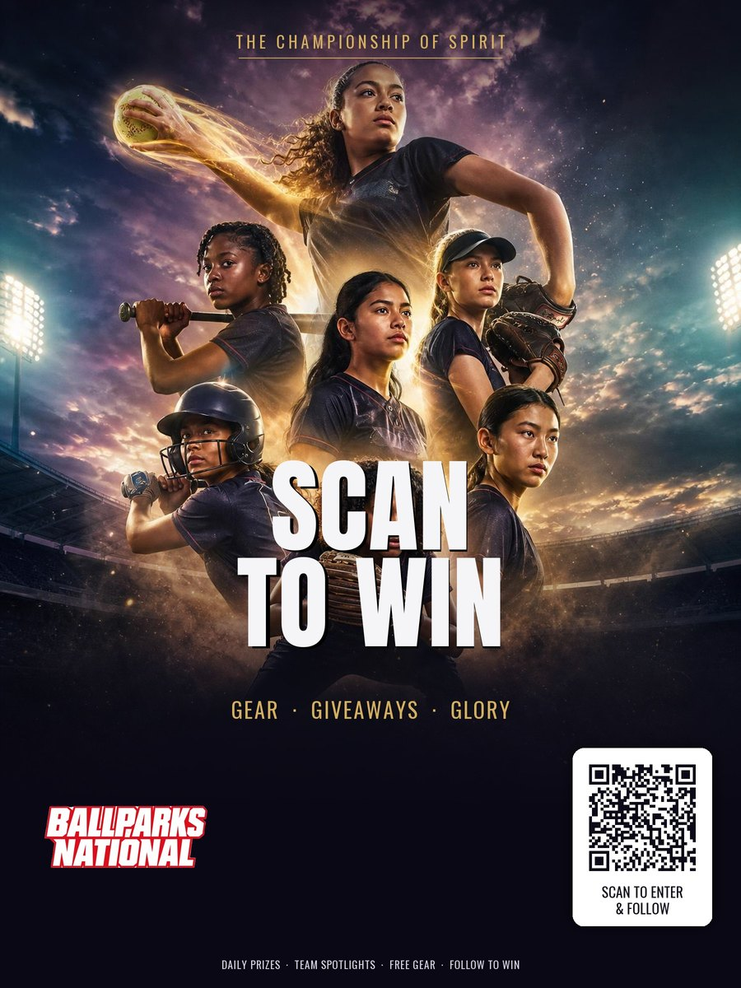
SCAN TO WIN — Gear · Giveaways · Glory
Highest-conversion follow driver via prizes and giveaways.

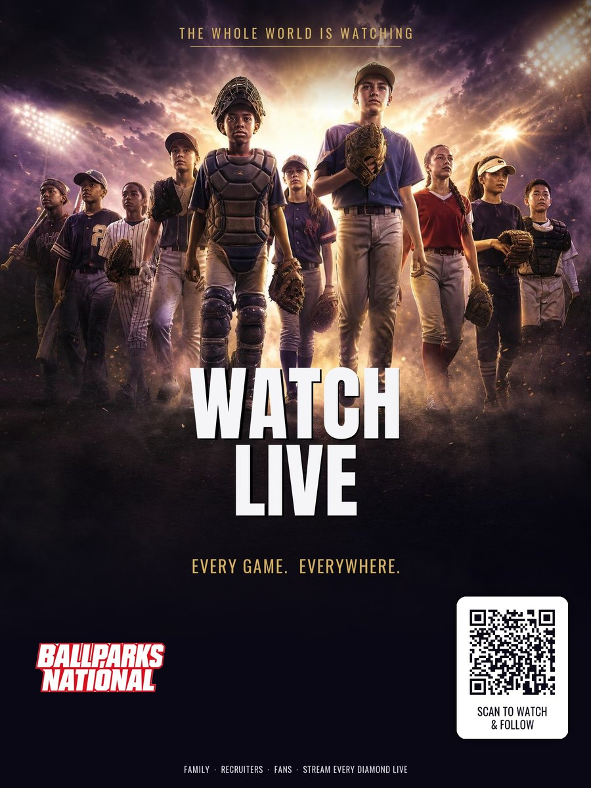
WATCH LIVE — Every Game · Everywhere
Sends families, recruiters and fans to the branded livestream.

